**AWS CCP PRACTICE QUESTIONS**

**(AWS Services and Technologies)**

Question 1:

Which AWS services can be used to decouple components of a microservices based application on AWS Cloud? (Select two)

1. Lambda
2. EC2
3. Step Function
4. SQS (Correct)
5. SNS (Correct)

#### **Explanation**

Correct option:

**SQS** - Amazon Simple Queue Service (SQS) is a fully managed message queuing service that enables you to decouple and scale microservices, distributed systems, and serverless applications. Using SQS, you can send, store, and receive messages between software components at any volume, without losing messages or requiring other services to be available.

**SNS** - Amazon Simple Notification Service (SNS) is a highly available, durable, secure, fully managed pub/sub messaging service that enables you to decouple microservices, distributed systems, and serverless applications. Using Amazon SNS topics, your publisher systems can fan-out messages to a large number of subscriber endpoints for parallel processing, including Amazon SQS queues, AWS Lambda functions, and HTTP/S webhooks. Additionally, SNS can be used to fan out notifications to end users using mobile push, SMS, and email.

Therefore, both SNS and SQS can be used to decouple components of a microservices-based application.

Please review this reference architecture for building a decoupled order processing system using SNS and SQS:

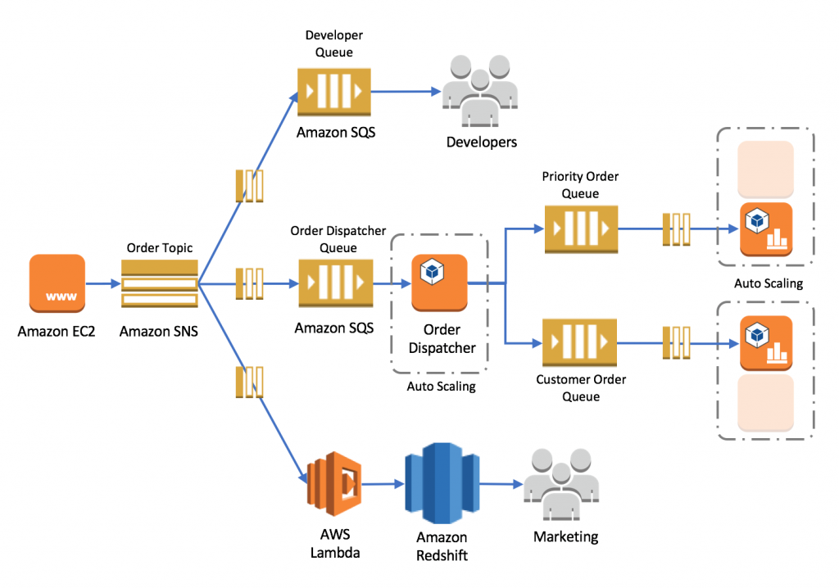

Incorrect options:

**EC2** - Amazon Elastic Compute Cloud (Amazon EC2) is a web service that provides secure, resizable compute capacity in the cloud with support for per-second billing. It is the easiest way to provision servers on AWS Cloud and access the underlying OS. EC2 cannot be used to decouple components of a microservices-based application.

**Lambda** - AWS Lambda lets you run code without provisioning or managing servers. You pay only for the compute time you consume. Lambda cannot be used to decouple components of a microservices-based application.

**Step Function** - AWS Step Function lets you coordinate multiple AWS services into serverless workflows. You can design and run workflows that stitch together services such as AWS Lambda, AWS Glue and Amazon SageMaker. Step Function cannot be used to decouple components of a microservices-based application.

Reference:

<https://aws.amazon.com/blogs/compute/building-loosely-coupled-scalable-c-applications-with-amazon-sqs-and-amazon-sns/>

<https://aws.amazon.com/microservices/>

Question 3:

Which of the following S3 storage classes takes the most time to retrieve data (also known as first byte latency)?

1. S3 Intelligent-Tiering
2. S3 Glacier
3. S3 Standard
4. S3 Glacier Deep Archive (Correct)

#### **Explanation**

Correct option:

"S3 Glacier Deep Archive" - S3 Glacier Deep Archive is Amazon S3’s lowest-cost storage class and supports long-term retention and digital preservation for data that may be accessed once or twice in a year. It is designed for customers — particularly those in highly-regulated industries, such as the Financial Services, Healthcare, and Public Sectors — that retain data sets for 7-10 years or longer to meet regulatory compliance requirements. S3 Glacier Deep Archive can also be used for backup and disaster recovery use cases. It has a retrieval time (first byte latency) of 12 to 48 hours.

Please review this illustration for S3 Storage Classes data retrieval times. You don't need to memorize the actual numbers, just remember that S3 Glacier Deep Archive takes the most time to retrieve data:

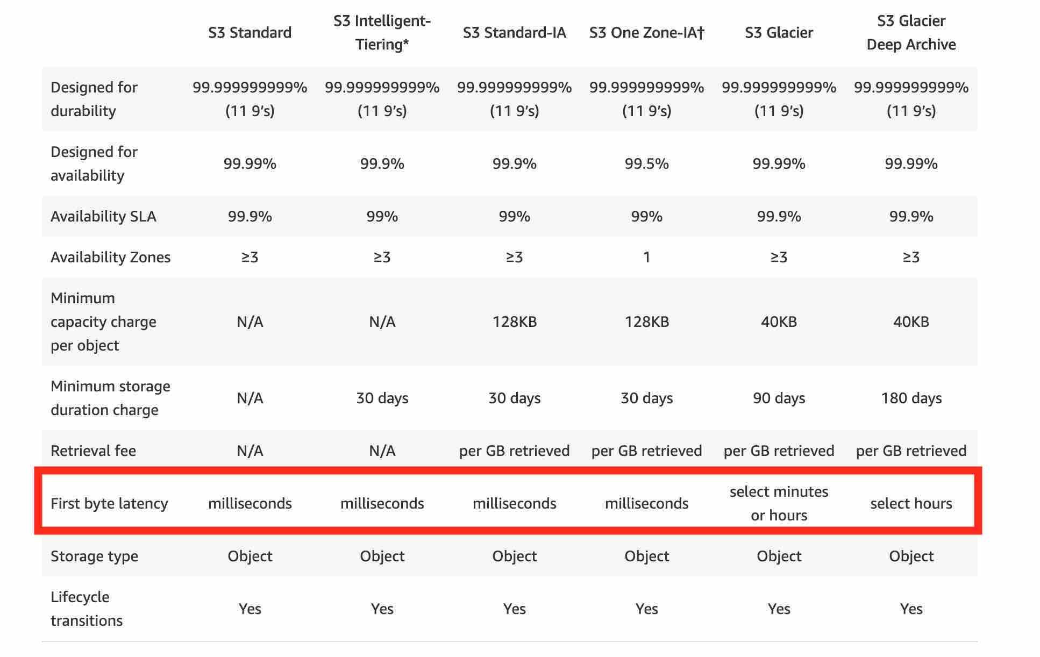

Incorrect options:

**S3 Standard** - S3 Standard offers high durability, availability, and performance object storage for frequently accessed data. S3 Standard has a retrieval time (first byte latency) of milliseconds.

**S3 Intelligent-Tiering** - The S3 Intelligent-Tiering storage class is designed to optimize costs by automatically moving data to the most cost-effective access tier, without performance impact or operational overhead. It works by storing objects in two access tiers: one tier that is optimized for frequent access and another lower-cost tier that is optimized for infrequent access. S3 Intelligent-Tiering has a retrieval time (first byte latency) of milliseconds.

**S3 Glacier** - Amazon S3 Glacier is a secure, durable, and extremely low-cost Amazon S3 cloud storage class for data archiving and long-term backup. It is designed to deliver 99.999999999% durability, and provide comprehensive security and compliance capabilities that can help meet even the most stringent regulatory requirements. S3 Glacier has a retrieval time (first byte latency) of minutes or a few hours.

Reference:

<https://aws.amazon.com/s3/storage-classes/>

Question 4:

A silicon valley based healthcare startup stores anonymized patient health data on Amazon S3. The CTO further wants to ensure that any sensitive data on S3 is discovered and identified. As a Cloud Practitioner, which AWS service would you recommend addressing this use-case?

1. Amazon Polly
2. Amazon Macie (Correct)
3. AWS Secrets Manager
4. AWS Glue

#### **Explanation**

Correct option:

**Amazon Macie** - Amazon Macie is a fully managed data security and data privacy service that uses machine learning and pattern matching to discover and protect your sensitive data in AWS. Macie automatically provides an inventory of Amazon S3 buckets including a list of unencrypted buckets, publicly accessible buckets, and buckets shared with AWS accounts outside those you have defined in AWS Organizations. Then, Macie applies machine learning and pattern matching techniques to the buckets you select to identify and alert you to sensitive data, such as personally identifiable information (PII).

How Macie Works:

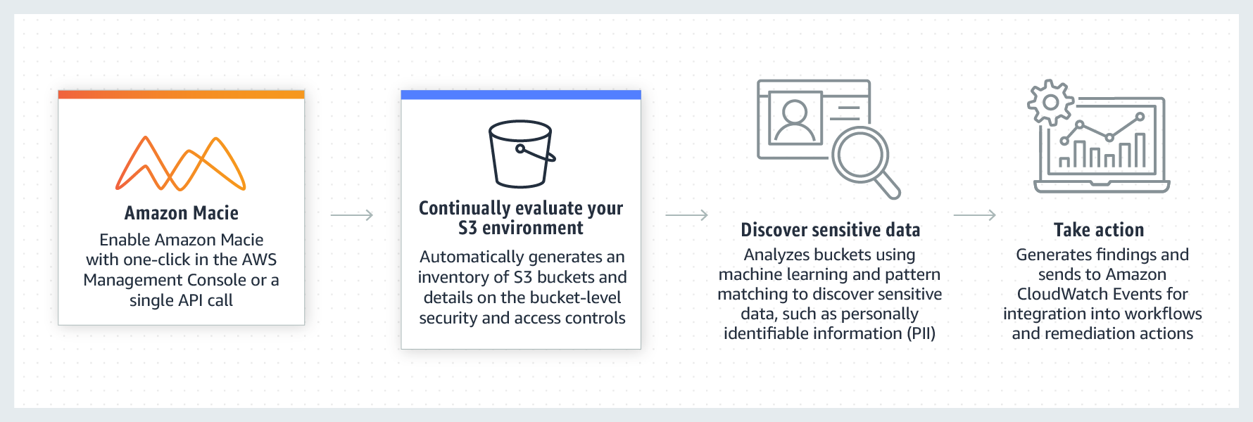

**AWS Glue** - AWS Glue is a fully managed extract, transform, and load (ETL) service that makes it easy for customers to prepare and load their data for analytics. AWS Glue job is meant to be used for batch ETL data processing. It cannot be used to discover and protect your sensitive data in AWS.

**Amazon Polly** - Amazon Polly is a service that turns text into lifelike speech, allowing you to create applications that talk, and build entirely new categories of speech-enabled products. Polly's Text-to-Speech (TTS) service uses advanced deep learning technologies to synthesize natural sounding human speech. It cannot be used to discover and protect your sensitive data in AWS.

**AWS Secrets Manager** - AWS Secrets Manager helps you protect secrets needed to access your applications, services, and IT resources. The service enables you to easily rotate, manage, and retrieve database credentials, API keys, and other secrets throughout their lifecycle. Users and applications retrieve secrets with a call to Secrets Manager APIs, eliminating the need to hardcode sensitive information in plain text. It cannot be used to discover and protect your sensitive data in AWS.

Reference:

<https://aws.amazon.com/macie/>

Question 5:

Which of the following represents a serverless stack on AWS Cloud?

1. Step Function, DynamoDB, EC2
2. EMR, DynamoDB, Lambda
3. Step Function, DynamoDB, Lambda (Correct)
4. EC2, DynamoDB, Lambda

#### **Explanation**

Correct option:

**Step Function, DynamoDB, Lambda**

AWS provides a set of fully managed services that you can use to build and run serverless applications. Serverless applications don’t require provisioning, maintaining, and administering servers for backend components such as compute, databases, storage, stream processing, message queueing, and more. You also no longer need to worry about ensuring application fault tolerance and availability.

The AWS serverless platform overview:

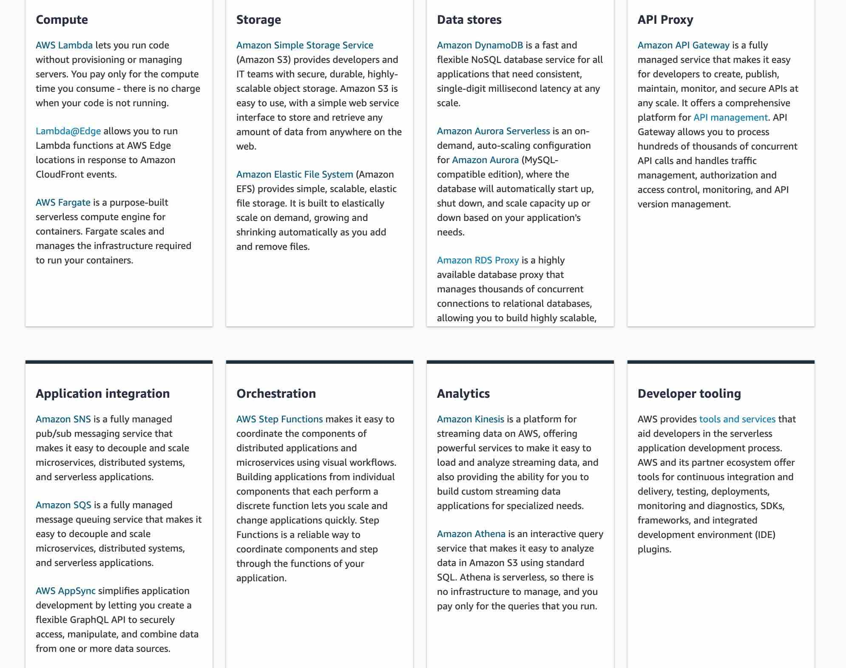

AWS Step Function lets you coordinate multiple AWS services into serverless workflows. You can design and run workflows that stitch together services such as AWS Lambda, AWS Glue and Amazon SageMaker.

Amazon DynamoDB is a key-value and document database that delivers single-digit millisecond performance at any scale. It's a fully managed, multi-Region, multi-master, durable database with built-in security, backup and restore, and in-memory caching for internet-scale applications.

AWS Lambda lets you run code without provisioning or managing servers.

Incorrect options:

Amazon EMR is the industry-leading cloud big data platform for processing vast amounts of data using open source tools such as Hadoop, Apache Spark, Apache Hive, Apache HBase, Apache Flink, Apache Hudi, and Presto. Amazon EMR can be used to provision resources to run big data workloads on Hadoop clusters. EMR provisions EC2 instances to manage its workload. EMR is not a serverless service.

Amazon Elastic Compute Cloud (Amazon EC2) is a web service that provides secure, resizable compute capacity in the cloud with support for per-second billing. It is the easiest way to provision servers on AWS Cloud and access the underlying OS. EC2 is not a serverless service.

**Step Function, DynamoDB, EC2**

**EMR, DynamoDB, Lambda**

**EC2, DynamoDB, Lambda**

As each of these three stacks has either EC2 or EMR, therefore, these options are incorrect.

Reference:

<https://aws.amazon.com/serverless/>

Question 6:

A data analytics company is running a proprietary batch analytics application on AWS and wants to use a storage service which would be accessed by hundreds of EC2 instances simultaneously to append data to existing files. As a Cloud Practitioner, which AWS service would you suggest for this use-case?

1. EFS (Correct)
2. S3
3. EBS
4. Instance Store

#### **Explanation**

Correct option:

"EFS" - Amazon EFS is a file storage service for use with Amazon EC2. Amazon EFS provides a file system interface, file system access semantics, and concurrently-accessible storage for up to thousands of Amazon EC2 instances. Amazon EFS uses the Network File System protocol.

How EFS works:

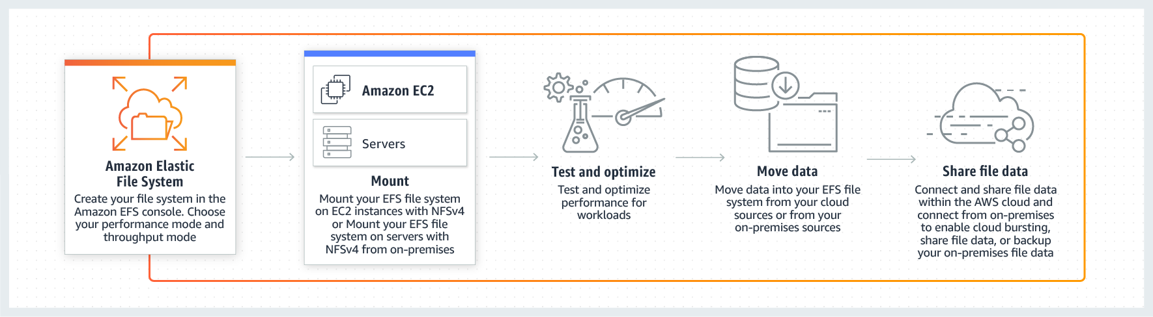

Incorrect options:

**EBS** - Amazon Elastic Block Store (EBS) is an easy to use, high-performance block storage service designed for use with Amazon Elastic Compute Cloud (EC2) for both throughput and transaction-intensive workloads at any scale. EBS volumes cannot be accessed simultaneously by multiple EC2 instances, so this option is incorrect.

**Instance Store** - An instance store provides temporary block-level storage for your instance. This storage is located on disks that are physically attached to the host computer. Instance Store volumes cannot be accessed simultaneously by multiple EC2 instances, so this option is incorrect.

**S3** - Amazon Simple Storage Service (Amazon S3) is an object storage service that offers industry-leading scalability, data availability, security, and performance. S3 is object storage and it does not support file append operations, so this option is incorrect.

Reference:

<https://aws.amazon.com/efs/>

Question 7:

Which tool/service will help you access AWS services using programming language-specific APIs?

1. AWS Management Console
2. AWS Software Developer Kit (SDK) (Correct)
3. Language-specific Integrated Development Environment (IDE)
4. AWS Command Line Interface (CLI)

#### **Explanation**

Correct option:

**AWS Software Developer Kit (SDK)** - SDKs take the complexity out of coding by providing language-specific APIs for AWS services. For example, the AWS SDK for JavaScript simpliﬁes the use of AWS Services by providing a set of libraries that are consistent and familiar for JavaScript developers. It provides support for API lifecycle considerations such as credential management, retries, data marshaling, serialization, and deserialization. AWS SDKs are offered in several programming languages to make it simple for developers working on different programming and scripting languages. So, AWS SDK can help with using AWS services from within an application using language-specific APIs.

Incorrect options:

**AWS Management Console** - The AWS Management Console is a web application that comprises and refers to a broad collection of service consoles for managing Amazon Web Services. When you first sign in, you see the console home page. The home page provides access to each service console as well as an intuitive user interface for exploring AWS and getting helpful tips.

**AWS Command Line Interface (CLI)** - The AWS Command Line Interface (CLI) is a unified tool to manage your AWS services. With just one tool to download and configure, you can control multiple AWS services from the command line and automate them through scripts. CLI cannot be used with language-specific APIs.

**Language-specific Integrated Development Environments (IDE)** - An integrated development environment (IDE) provides a set of coding productivity tools such as a source code editor, a debugger, and build tools. Cloud9 IDE is an offering from AWS under IDEs.

References:

<https://aws.amazon.com/tools/>

<https://aws.amazon.com/cli/>

Question 8:

Which AWS services can be used to facilitate organizational change management, part of the Reliability pillar of AWS Well-Architected Framework? (Select three)

1. Amazon Inspector
2. Amazon GuardDuty
3. AWS Trusted Advisor
4. AWS Config (Correct)
5. AWS CloudTrail (Correct)
6. Amazon CloudWatch (Correct)

#### **Explanation**

Correct options:

There are three best practice areas for Reliability in the cloud - Foundations, Change Management, Failure Management. Being aware of how change affects a system (change management) allows you to plan proactively, and monitoring allows you to quickly identify trends that could lead to capacity issues or SLA breaches.

**AWS Config** - AWS Config is a service that enables you to assess, audit, and evaluate the configurations of your AWS resources. Config continuously monitors and records your AWS resource configurations and allows you to automate the evaluation of recorded configurations against desired configurations.

How AWS Config Works:

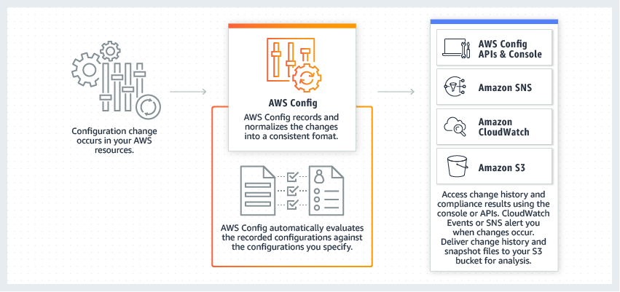

**AWS CloudTrail** - AWS CloudTrail is a service that enables governance, compliance, operational auditing, and risk auditing of your AWS account. With CloudTrail, you can log, continuously monitor, and retain account activity related to actions across your AWS infrastructure. CloudTrail provides event history of your AWS account activity, including actions taken through the AWS Management Console, AWS SDKs, command-line tools, and other AWS services.

How CloudTrail Works:

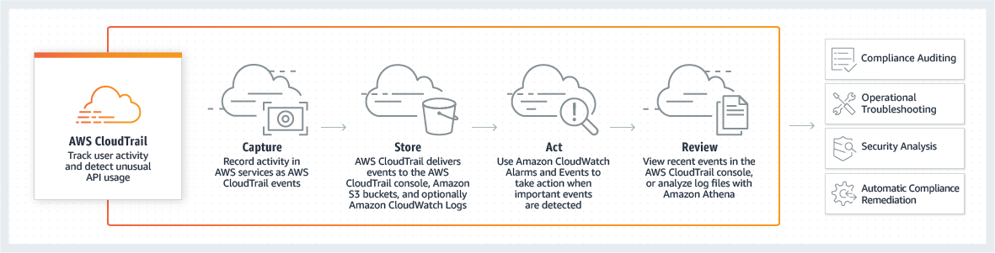

**Amazon CloudWatch** - Amazon CloudWatch is a monitoring and observability service built for DevOps engineers, developers, site reliability engineers (SREs), and IT managers. CloudWatch provides data and actionable insights to monitor applications, respond to system-wide performance changes, optimize resource utilization, and get a unified view of operational health.

Incorrect options:

**AWS Trusted Advisor** - AWS Trusted Advisor is an online tool that provides you real-time guidance to help you provision your resources following AWS best practices on cost optimization, security, fault tolerance, service limits, and performance improvement.

**Amazon Inspector** - Amazon Inspector is an automated security assessment service that helps improve the security and compliance of applications deployed on AWS. Amazon Inspector automatically assesses applications for exposure, vulnerabilities, and deviations from best practices.

**Amazon GuardDuty** - Amazon GuardDuty is a threat detection service that monitors malicious activity and unauthorized behavior to protect your AWS account. GuardDuty analyzes billions of events across your AWS accounts from AWS CloudTrail (AWS user and API activity in your accounts), Amazon VPC Flow Logs (network traffic data), and DNS Logs (name query patterns). This service is for AWS account level access, not for instance-level management like an EC2. GuardDuty cannot be used to check OS vulnerabilities.

References:

<https://d1.awsstatic.com/whitepapers/architecture/AWS_Well-Architected_Framework.pdf>

<https://aws.amazon.com/config/>

<https://aws.amazon.com/cloudtrail/>

Question 9:

Which of the following is a serverless AWS service?

1. Beanstalk
2. EC2
3. EMR
4. Lambda (Correct)

#### **Explanation**

Correct option:

**Lambda** - AWS Lambda lets you run code without provisioning or managing servers. You pay only for the compute time you consume. With Lambda, you can run code for virtually any type of application or backend service - all with zero administration. Just upload your code and Lambda takes care of everything required to run and scale your code with high availability.

How Lambda Works:

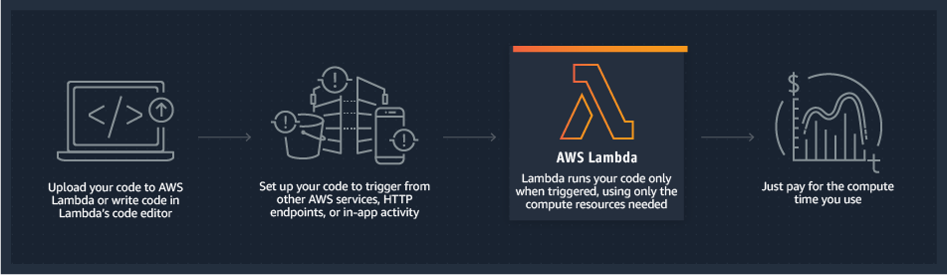

Incorrect options:

**EC2** - Amazon Elastic Compute Cloud (Amazon EC2) is a web service that provides secure, resizable compute capacity in the cloud with support for per-second billing. It is the easiest way to provision servers on AWS Cloud and access the underlying OS. EC2 is not a serverless service.

**EMR** - Amazon EMR is the industry-leading cloud big data platform for processing vast amounts of data using open source tools such as Hadoop, Apache Spark, Apache Hive, Apache HBase, Apache Flink, Apache Hudi, and Presto. Amazon EMR can be used to provision resources to run big data workloads on Hadoop clusters. EMR provisions EC2 instances to manage its workload. EMR is not a serverless service.

**Beanstalk** - AWS Elastic Beanstalk is an easy-to-use service for deploying and scaling web applications and services. You simply upload your code and Elastic Beanstalk automatically handles the deployment, from capacity provisioning, load balancing, auto-scaling to application health monitoring. Beanstalk provisions servers so it is not a serverless service.

Reference:

<https://aws.amazon.com/lambda/>

Question 10:

Which of the following are the storage services offered by the AWS Cloud? (Select two)

1. SNS
2. SQS
3. EFS (Correct)
4. S3 (Correct)
5. EC2

#### **Explanation**

Correct options:

**S3** - Amazon Simple Storage Service (Amazon S3) is an object storage service that offers industry-leading scalability, data availability, security, and performance.

**EFS** - Amazon Elastic File System (Amazon EFS) provides a simple, scalable, fully managed elastic NFS file system for use with AWS Cloud services and on-premises resources. It is built to scale on-demand to petabytes without disrupting applications, growing and shrinking automatically as you add and remove files, eliminating the need to provision and manage capacity to accommodate growth.

Incorrect options:

**EC2** - Amazon EC2 is a web service that provides secure, resizable compute capacity in the AWS cloud. You can use EC2 to provision virtual servers on AWS Cloud.

**SQS** - Amazon Simple Queue Service (SQS) is a fully managed message queuing service that enables you to decouple and scale microservices, distributed systems, and serverless applications. Using SQS, you can send, store, and receive messages between software components at any volume, without losing messages or requiring other services to be available.

**SNS** - Amazon Simple Notification Service (SNS) is a highly available, durable, secure, fully managed pub/sub messaging service that enables you to decouple microservices, distributed systems, and serverless applications. Using Amazon SNS topics, your publisher systems can fan-out messages to a large number of subscriber endpoints for parallel processing, including Amazon SQS queues, AWS Lambda functions, and HTTP/S webhooks. Additionally, SNS can be used to fan out notifications to end users using mobile push, SMS, and email.

Reference:

Question 11:

Which of the following statements are CORRECT regarding the Availability Zone (AZ) specific characteristics of EBS and EFS storage types?

1. EBS volume can be attached to one or more instances in multiple Availability Zones and EFS file system can be mounted on instances in the same Availability Zone.
2. EBS volume can be attached to a single instance in the same Availability Zones and EFS file system can be mounted on instances across Multiple Availability Zones. (Correct)
3. EBS volume can be attached to one or more instances in multiple Availability Zones and EFS file system can be mounted on instances across multiple Availability Zones.
4. EBS volumes can be attached to a single instance in the same Availability Zone and EFS file system can only be mounted on instances in the same Availability Zone.

#### **Explanation**

Correct options:

**EBS volume can be attached to a single instance in the same Availability Zone whereas EFS file system can be mounted on instances across multiple Availability Zones**

Amazon Elastic File System (Amazon EFS) provides a simple, scalable, fully managed elastic NFS file system for use with AWS Cloud services and on-premises resources. It is built to scale on-demand to petabytes without disrupting applications, growing and shrinking automatically as you add and remove files, eliminating the need to provision and manage capacity to accommodate growth.

The service is designed to be highly scalable, highly available, and highly durable. Amazon EFS file systems store data and metadata across multiple Availability Zones in an AWS Region. EFS file system can be mounted on instances across multiple Availability Zones.

Amazon Elastic Block Store (EBS) is an easy to use, high-performance block storage service designed for use with Amazon Elastic Compute Cloud (EC2) for both throughput and transaction-intensive workloads at any scale.

Designed for mission-critical systems, EBS volumes are replicated within an Availability Zone (AZ) and can easily scale to petabytes of data. You can attach an available EBS volume to one instance that is in the same Availability Zone as the volume.

Incorrect options:

**EBS volume can be attached to one or more instances in multiple Availability Zones and EFS file system can be mounted on instances in the same Availability Zone**

**EBS volume can be attached to a single instance in the same Availability Zone and EFS file system can only be mounted on instances in the same Availability Zone**

**EBS volume can be attached to one or more instances in multiple Availability Zones and EFS file system can be mounted on instances across multiple Availability Zones**

These three options contradict the details provided earlier in the explanation, so these options are incorrect.

References:

<https://aws.amazon.com/efs/faq/>

<https://docs.aws.amazon.com/AWSEC2/latest/UserGuide/ebs-attaching-volume.html>

<https://docs.aws.amazon.com/AWSEC2/latest/UserGuide/ebs-volumes-multi.html>

Question 13:

A company wants to identify the optimal AWS resource configuration for its workloads so that the company can reduce costs and increase workload performance. Which of the following services can be used to meet this requirement?

1. AWS Systems Manager
2. AWS Budgets
3. AWS Compute Optimizer (Correct)
4. AWS Cost Explorer

#### **Explanation**

Correct option: **AWS Compute Optimizer** - AWS Compute Optimizer recommends optimal AWS resources for your workloads to reduce costs and improve performance by using machine learning to analyze historical utilization metrics. Over-provisioning resources can lead to unnecessary infrastructure costs, and under-provisioning resources can lead to poor application performance. Compute Optimizer helps you choose optimal configurations for three types of AWS resources: Amazon EC2 instances, Amazon EBS volumes, and AWS Lambda functions, based on your utilization data.

Compute Optimizer recommends up to 3 options from 140+ EC2 instance types, as well as a wide range of EBS volume and Lambda function configuration options, to right-size your workloads. Compute Optimizer also projects what the CPU utilization, memory utilization, and run time of your workload would have been on recommended AWS resource options. This helps you understand how your workload would have performed on the recommended options before implementing the recommendations.

How Compute Optimizer works:

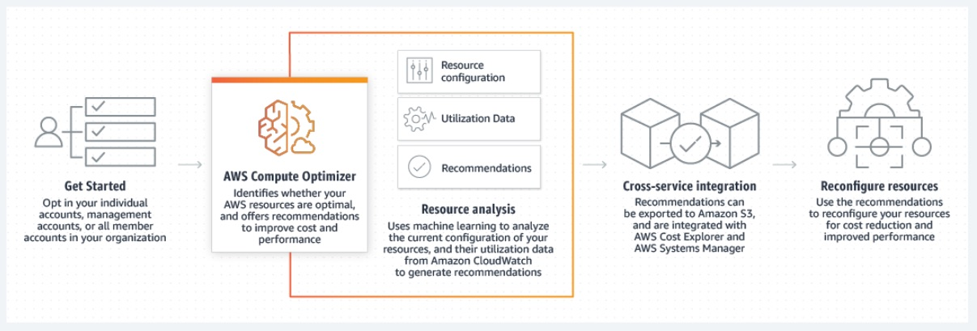

Incorrect options:

**AWS Systems Manager** - AWS Systems Manager is the operations hub for AWS. Systems Manager provides a unified user interface so you can track and resolve operational issues across your AWS applications and resources from a central place. With Systems Manager, you can automate operational tasks for Amazon EC2 instances or Amazon RDS instances. You can also group resources by application, view operational data for monitoring and troubleshooting, implement pre-approved change workflows, and audit operational changes for your groups of resources. Systems Manager simplifies resource and application management, shortens the time to detect and resolve operational problems, and makes it easier to operate and manage your infrastructure at scale. Systems Manager cannot be used to identify the optimal resource configuration for workloads running on AWS.

**AWS Budgets** - AWS Budgets allows you to set custom budgets to track your cost and usage from the simplest to the most complex use cases. With AWS Budgets, you can choose to be alerted by email or SNS notification when actual or forecasted cost and usage exceed your budget threshold, or when your actual RI and Savings Plans' utilization or coverage drops below your desired threshold. With AWS Budget Actions, you can also configure specific actions to respond to cost and usage status in your accounts, so that if your cost or usage exceeds or is forecasted to exceed your threshold, actions can be executed automatically or with your approval to reduce unintentional over-spending.

**AWS Cost Explorer** - AWS Cost Explorer has an easy-to-use interface that lets you visualize, understand, and manage your AWS costs and usage over time. Cost Explorer Resource Rightsizing Recommendations and Compute Optimizer use the same recommendation engine. The Compute Optimizer recommendation engine delivers recommendations to help customers identify optimal EC2 instance types for their workloads. The Cost Explorer console and API surface a subset of these recommendations that may lead to cost savings, and augments them with customer-specific cost and savings information (e.g. billing information, available credits, RI, and Savings Plans) to help Cost Management owners quickly identify savings opportunities through infrastructure rightsizing. Compute Optimizer console and its API delivers all recommendations regardless of the cost implications.

Reference:

<https://aws.amazon.com/compute-optimizer/>

Question 14:

Which of the following is an AWS database service?

1. Redshift (Correct)
2. Glue
3. Database Migration Service
4. Storage Gateway

#### **Explanation**

Correct option:

**Redshift** - Amazon Redshift is a fully-managed petabyte-scale cloud-based data warehouse product designed for large scale data set storage and analysis.

Incorrect options:

**Glue** - AWS Glue is a fully managed extract, transform, and load (ETL) service that makes it easy for customers to prepare and load their data for analytics.

**Storage Gateway** - AWS Storage Gateway is a hybrid cloud storage service that connects your existing on-premises environments with the AWS Cloud. Customers use Storage Gateway to simplify storage management and reduce costs for key hybrid cloud storage use cases.

**Database Migration Service** - AWS Database Migration Service helps you migrate databases to AWS quickly and securely. The source database remains fully operational during the migration, minimizing downtime to applications that rely on the database. The AWS Database Migration Service can migrate your data to and from the most widely used commercial and open-source databases.

References:

<https://aws.amazon.com/redshift/>

<https://aws.amazon.com/dms/>

Question 15:

A research group wants to use EC2 instances to run a scientific computation application that has a fault tolerant architecture. The application needs high-performance hardware disks that provide fast I/O performance. As a Cloud Practitioner, which of the following storage options would you recommend as the MOST cost-effective solution?

1. Instance Store (Correct)
2. EBS
3. EFS
4. S3

#### **Explanation**

Correct option:

**Instance Store**

An instance store provides temporary block-level storage for your instance. This storage is located on disks that are physically attached to the host computer. This is a good option when you need storage with very low latency, but you don't need the data to persist when the instance terminates or you can take advantage of fault-tolerant architectures. For this use-case, the computation application itself has a fault tolerant architecture, so it can automatically handle any failures of Instance Store volumes.

As the Instance Store volumes are included as part of the instance's usage cost, therefore this is the correct option.

EC2 Instances Store Overview:

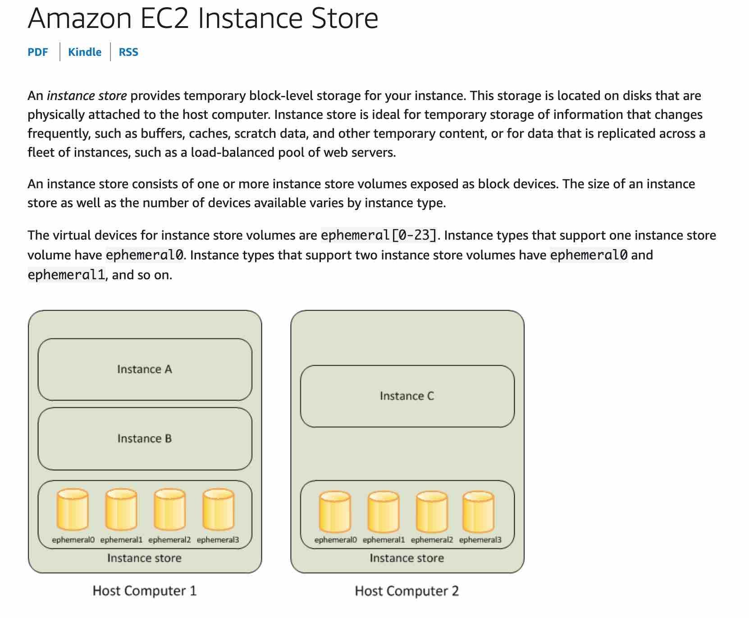

Incorrect options:

**EFS** - Amazon Elastic File System (Amazon EFS) provides a simple, scalable, fully managed, elastic NFS file system. EFS is not available as a hardware disk on the instance, so this option is not correct.

**EBS** - Amazon Elastic Block Store (EBS) is an easy to use, high-performance block storage service designed for use with Amazon Elastic Compute Cloud (EC2) for both throughput and transaction-intensive workloads at any scale. EBS is not available as a hardware disk on the instance, so this option is not correct.

**S3** - Amazon Simple Storage Service (Amazon S3) is an object storage service that offers industry-leading scalability, data availability, security, and performance. S3 is not available as a hardware disk on the instance, so this option is not correct.

Reference:

<https://docs.aws.amazon.com/AWSEC2/latest/UserGuide/InstanceStorage.html>

Question 16:

Which of the following entities applies patches to the underlying OS for AWS Aurora?

1. The AWS Product Team automatically (Correct)
2. The AWS Support after receiving a request from another customer
3. The AWS customer by SSHing on the instance
4. The AWS customer by using AWS Systems Manager

#### **Explanation**

Correct option:

**The AWS Product Team automatically**

Amazon Aurora is a MySQL and PostgreSQL-compatible relational database built for the cloud. Amazon Aurora is fully managed by Amazon Relational Database Service (RDS), which automates time-consuming administration tasks like hardware provisioning, database setup, patching, and backups. The AWS Product team is responsible for applying patches to the underlying OS for AWS Aurora.

Incorrect options:

**The AWS customer by using AWS Systems Manager** - AWS Systems Manager gives you visibility and control of your infrastructure on AWS. Systems Manager provides a unified user interface so you can view operational data from multiple AWS services and allows you to automate operational tasks such as running commands, managing patches and configuring servers across AWS Cloud as well as on-premises infrastructure. You can only use AWS Systems Manager to apply patches to your EC2 instances or on-premises instances. You cannot use Systems Manager to apply patches to the underlying OS for AWS Aurora.

**The AWS Support after receiving a request from the customer** - AWS Support handles support tickets regarding AWS services. AWS Support is not responsible for applying patches to the underlying OS for AWS Aurora.

**The AWS customer by SSHing on the instances** - AWS customers are only responsible for patching their own EC2 instances.

Reference:

<https://aws.amazon.com/rds/aurora/>

Question 17:

A unicorn startup is building an analytics application with support for a speech-based interface. The application will accept speech-based input from users and then convey results via speech. As a Cloud Practitioner, which solution would you recommend for the given use-case?

41